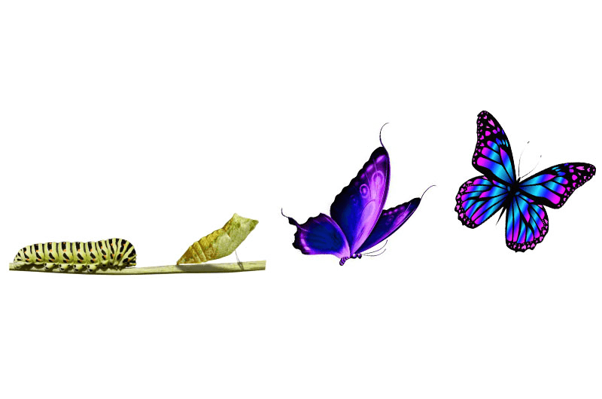 The Power to Transform Reflection Assessment
Name:

Phase 1: Caterpillar
The starting point (where are you now in your process of transformation? What needs to be changed or transformed in you?)

Phase 2: Metamorphosis
What are actions you need to take in order to move towards the Butterfly?

Phase 3: The Butterfly
What does progress look like to you? What are indicators of progress?

